Read

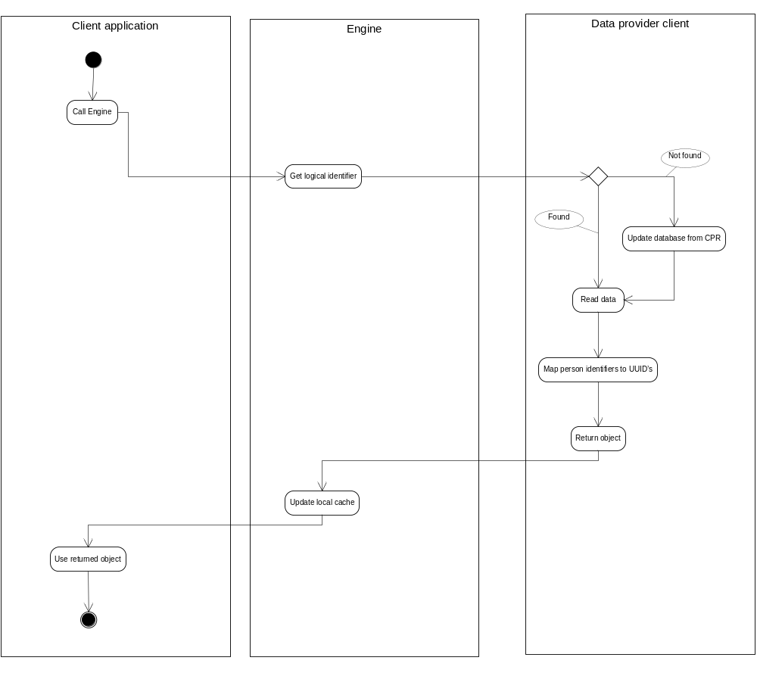

Search
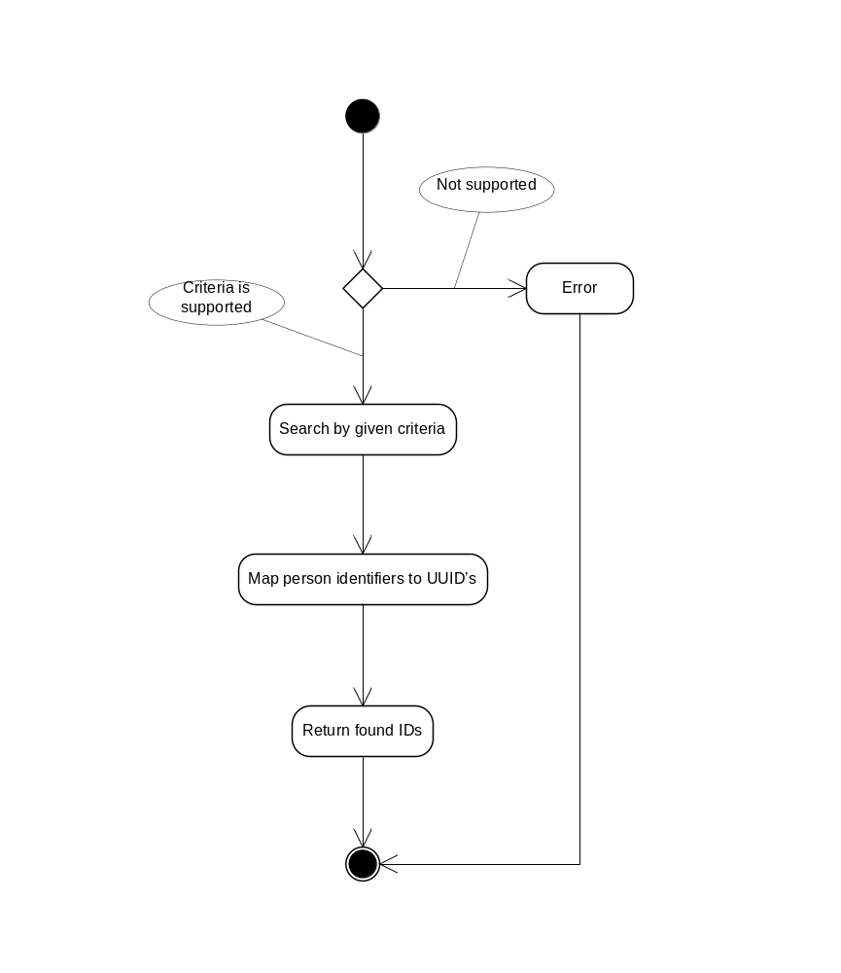

Questions
- When calling ‘Search’, what should be done if there is a criterion that cannot be searched by the data source? Possible options are
- Raise an error
- Ignore that specific criterion
- Temporarily ignore the criterion and do an in memory filter
- Permanently ignore the criterion and show a warning message
- On the other hand, if the criteria is empty or too wide for a reasonable (or possible) search
- Return error and ask the caller for a more strict criteria
- Return all matches (bad option)
- Return first N matches and a warning message (where N is a setting)

Actors
Actors will be supported to a limited extent. In the broker’s context, an actor is a data provider used by the broker to get data.
When a data provider is added, there will be a need to supply an object ID that equals the UUID of the IT system represented by the data provider.
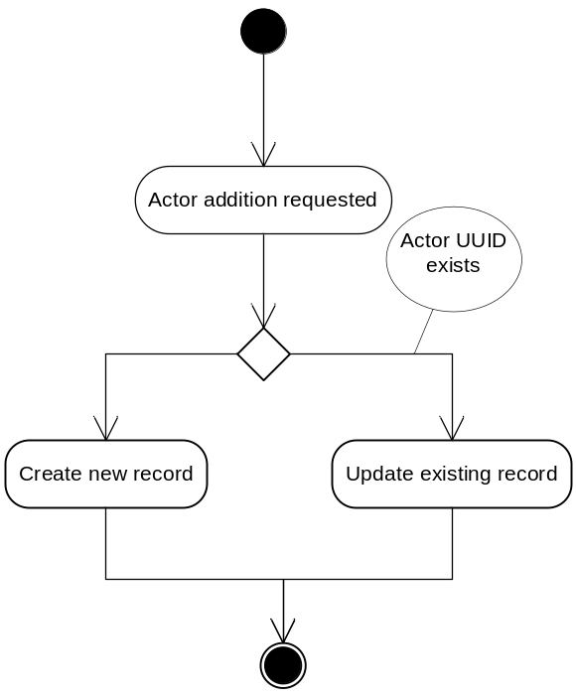

Registrations
There seems to be a need to have triple history rather than dual. The three time perspectives are
- Effect date: the date when the action took effect(getting married)
- Registration date: the date when the action was registered (registration of marriage in CPR)
- Broker update date: the date when CPR broker created the local registration.
The last perspective is not necessarily visible to the broker’s clients.

Local cache update
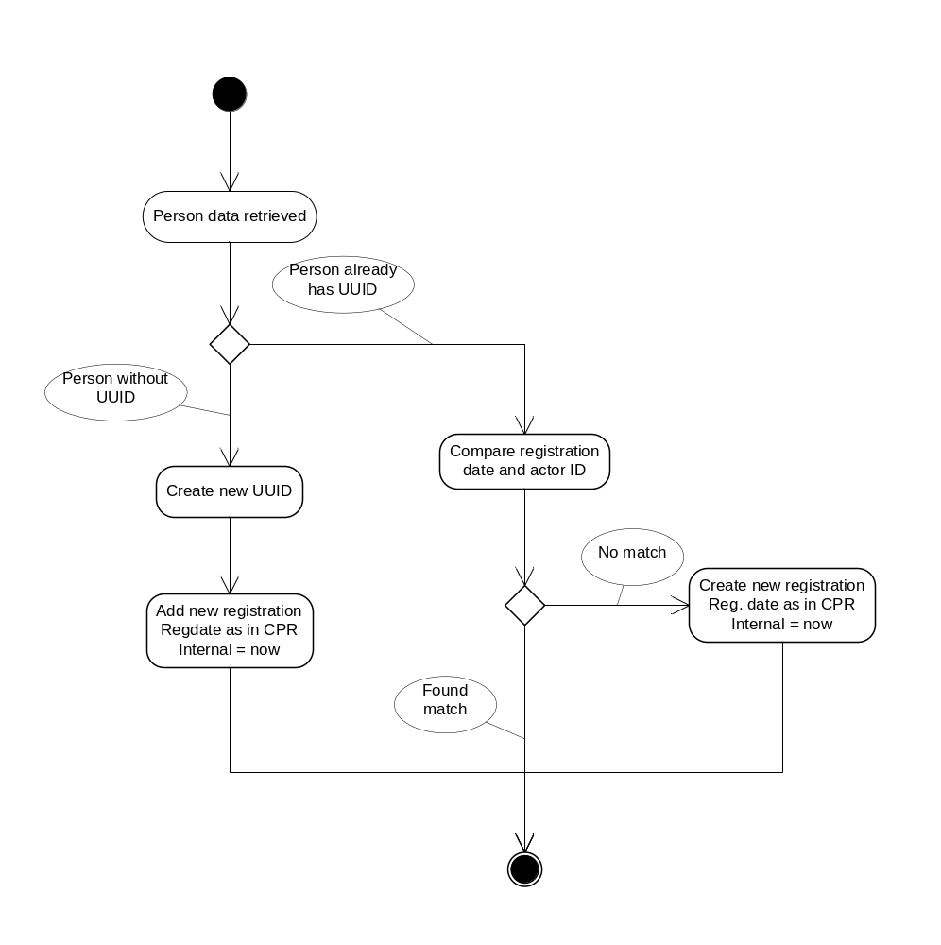

Import
Uniqueness can be achieved by a partial or full implementation of ‘Import’ operation. A draft can be like this
